|  |  |
| --- | --- |
| **Ex No: 7**  **Date: 11/09/24** | **Autoencoder using the Fashion MNIST Dataset**  **(With Denoising the dataset)** |

**Objective:**

To build an autoencoder that denoises Fashion MNIST images by compressing them into a lower-dimensional representation and reconstructing the original images from the compressed format.

**Descriptions:**

In this exercise, we broke the implementation down into three steps:

**Data Preparation:**

* Fashion MNIST images are loaded and normalized using TensorFlow Datasets (TFDS).
* Noise is added to the images, and the noisy images are used as inputs to the model, while the clean images are used as targets.

**Model Architecture:**

* **Encoder:** Consists of two Conv2D layers followed by MaxPooling layers, reducing the image size while extracting features.
* **Bottleneck:** A dense representation compresses the information further.
* **Decoder:** Upsamples the compressed representation back to the original image size using Conv2D and UpSampling2D layers.

**Training:**

* The model is compiled with the Adam optimizer and binary cross-entropy loss.
* The training is performed for 40 epochs with a batch size 128.

**Model:**

**Encoder:**

* Two convolutional layers with 64 and 128 filters respectively, each followed by a MaxPooling layer.
* Compresses the image down to a smaller representation.

**Bottleneck:**

* A convolutional layer with 256 filters that acts as the compressed representation layer.

**Decoder:**

* Two convolutional layers that upsample the encoded representation back to the original image size.

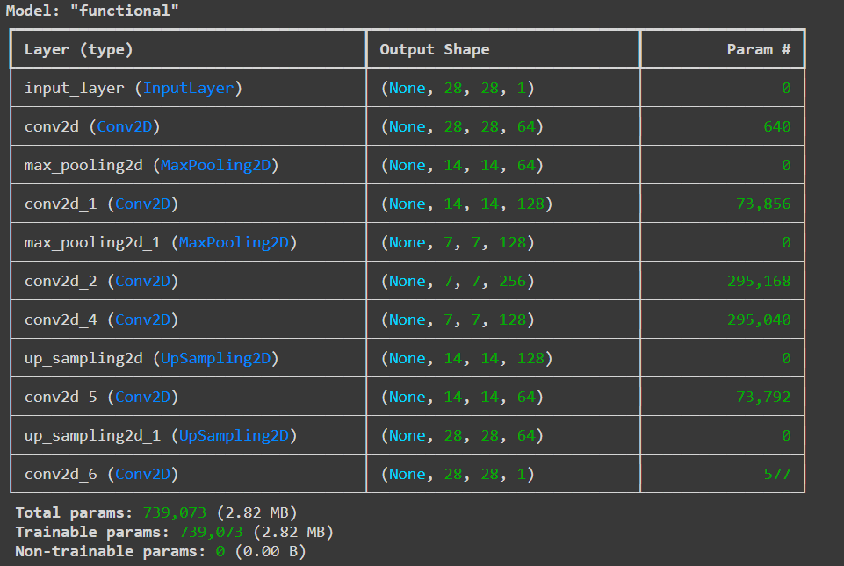

**Result and Analysis:**

The autoencoder learned to denoise the images by reconstructing them from noisy inputs. The clean outputs show that the model effectively removed noise, retaining key details of the original images.

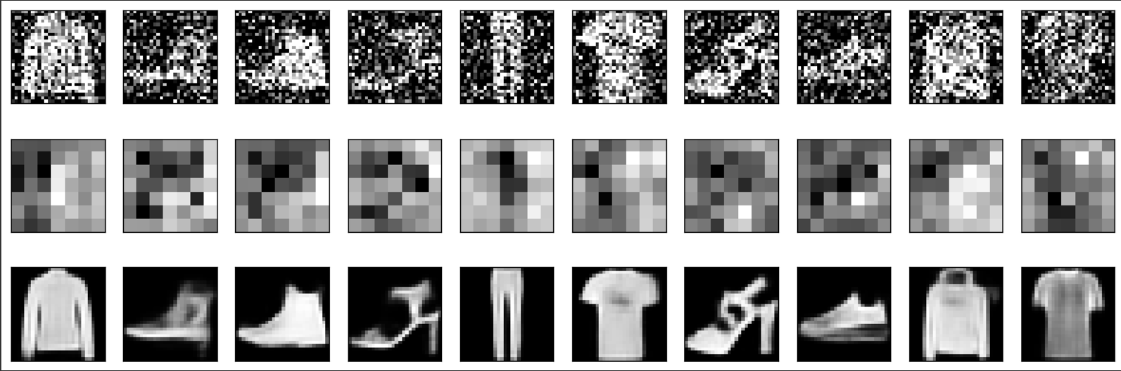

**GitHub Link:**

<https://github.com/FMS07/Fundamentals_of_DL/tree/main/Lab06_4%20-%20Denoising_Autoencoder>